**Campus Placement System**

# Abstract

The system focuses on automation of conventional training and placement management system. This system can be used as an application for the Training & Placement Officers in the college to manage the student information with regard to placement and providing assistance using the assistance portal where students can post their query to the TPO and coordinators. Providing Student login helping them to update their personal and educational information in a form which will be added to the database and upload a resume and providing them with preparation materials for placements. An additional feature of the portal is a Company Tab which will be providing assistance to the companies to shortlist the students as per their eligibility criteria. It reduces the manual work and consumes less paperwork to reduce the time. Front end of the system is developed with the help of CSS, Bootstrap, and HTML.

Backend of this system will be managed with the help of PHP, Android and XML. Database management of this system will be done with the help of MYSQL database.

Online Training and Placement system automates activities of Training and placement cell and place the best coordination between student. It provide student community to use collective intelligence to increase selection ratio and eases out process of creation of management information automatically. Online Training and Placement focuses on automation of placement cell. Authorizing the CV, communicating about the various job openings to the student community, managing the corporate relationship for inviting them for the placements as well other activities, monitoring the progress of the selection process and communicating with different users.

**Keyword:**SMS Integration, CV, Coordination, Authentication , Secure.

# Chapter-1

# Introduction

**1. Introduction**

In today’s world everyone is travelling for jobs after Completion of their

Graduation. It has become need for each and every student, but for that they need to travel worldwide in searching of jobs. For simplicity of this whole hectic procedures we had proposed Online Training and Placement System because of earlier system is totally done manually by maintaining records, time consuming and very difficult to maintain coordination between student and companies.

The project is aimed at developing an online web application for the training and placement department of the college. The system is an online web application that can be accessed throughout the Institute with proper login provided. This system can be used as an application for the TPO of the college to manage the student information with regard to placement. Student logging should be able to upload their information. Organizations representatives logging in may also access/search an information put up by the students. TPO have to collect the information and manage them manually according to various streams. If any modification is required that is also to be done manually. Overall it will reduce the paper work and utilize the maximum capability of the setup and organization as well as it will save time and money.

## 1.1 Problem definition and scope of project

Students choose a specific college where the placement will be held,

there is a need to maintain all these papers, causing large amount of space. It is manually done, chances of missing, difficult to handle the details of student.

**Scope of project:** Our project has a big scope to do. Students can access previous information about placement. We can stores information of all students. Various companies can access their information. Notifications are sent to students about the companies.

1. Easy to collect and manage student data.

1. To increase the accuracy and efficiency of placement procedure.
2. Reduce the paper work.
3. Analysis of overall placement activities

Other features such as giving notification to students about the jobs that are available both on and off campus can be included in the upgraded versions. The system cannot provide the SMS integration. Hence, it can be modified to give the SMS integration. Other features like analytics can be added in future to this portal for tracking the progress of student in specific areas. After analysis this system will notify students of the areas they are lacking in.

**Justification of problem**

## ▪ Existing System

All processes in existing system are handled manually. All the work that is done in the existing system is done by the human intervention .As all the work is done manually, there were a lot of workload on placement officer and it also increases the maximum chances of errors. This is so slow and time consuming. Due to increase in number of user’s the process become more difficult. Problems faced in existing system are as follows-

* Searching of eligible students is done manually by TPO based on the company criteria.
* The records were stored in modified excel sheets hence sorting problem.
* The duplication of records was usual hence data redundancy.
* TPO’s have to collect all the information and Resumes of students and organize them manually and sort them according to various streams.

• Collecting CV’s of so many student is a painful and time consuming task and handling of too many CV’s is a great overhead.

• It takes too much time to managing, updating and informing specific student for specific company criteria.

## ▪ Proposed System

The main purpose of proposed Web based Training and Placement portal is meant to give more easiness to TPO, Placement coordinators and Students that they can modify and access information so quickly. The system provides a better way to maintain students information in the database, ensures data correctness and data integrity as well. The system also reduces the paperwork time and provides an efficient information flow between different system modules. Our system consists of different modules to interact with. Firstly, on opening the web portal you’ll land on the main page of the portal which showcases information about the college. Secondly ,there are three tabs given in the portal namely T&P, Student ,and Company. Each module has the same login page consisting of user id and password field for gaining access to the functionalities of the system. in the portal namely T&P, Student, and Company. Each module has the same login page that contain user id and password field, by entering data in these field the user can gain access to the functionalities.

## 1.2 Need for the new system

College training and placement (CTAP) system provides the modules like • Student

* Admin
* Student can view company data
* Admin dashboard has overall functional rights
* Appropriate data processing and handling

## Student Module

This Module consist of a login option and registration window for unregistered students. Students will use their choice of username and a proper specified length password. The functionalities provided in this module consist of:

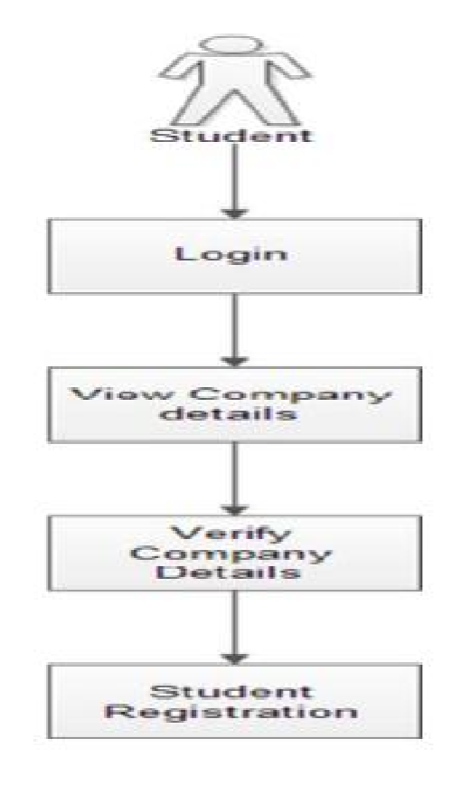

* It helps the Students to update their details anytime.
* The students would be able to view the company requirement.
* Students will be provided with a link to apply for the company if eligible.
* Previous Years placement paper and material is also provided.
* Students can see the complete profile of the company. Such as recruitment procedure history CTC offer and the working environment.

## The T&P(Admin) Module

has the authority to manage various functionalities of the system. This module will be handled by an Admin (say Training and placement Officer) who has the authority to:

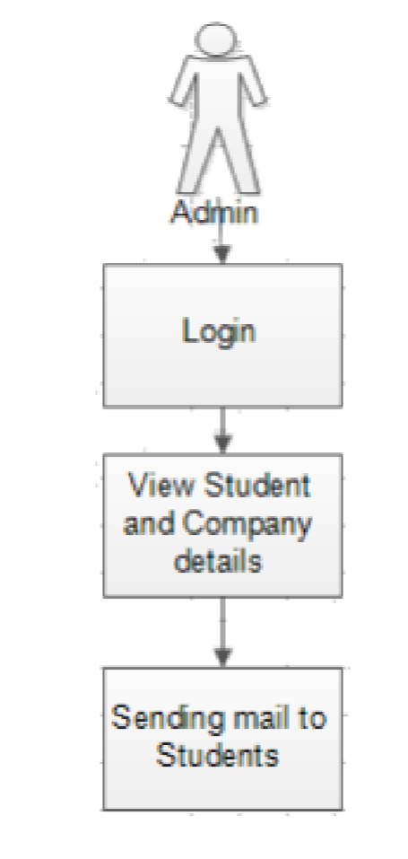

* Add company details
* Provides authentication for registered students
* Add news feed and
* Update company data. Overall records of the students will be presented over the portal like the data of all placed and unplaced students which will reduce the bottleneck of confusion among students.

# 1.3 Project Scope

The aim of the proposed system is to develop a system with improved facilities. The proposed system can overcome all the limitation of the existing system, such as student’s information is maintained in the database, it gives more security to data, ensures data accuracy, reduces paper work and save time, only eligible students get chance, it makes information flow efficient and paves way for easy report generation, reduce the space. Proposed system is cost effective.

**Project estimate**

For a successful project we first need to estimate the various resources that are required to complete the project. Effective software project estimation is an important activity in any software development project. One of the main reasons software programs fail is our inability to accurately estimate software size. Because we almost always estimate size too low, we do not adequately fund or allow enough time for development. Poor size estimates are usually at the heart of cost and schedule overruns.

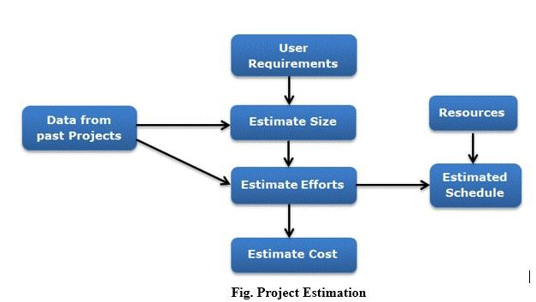

**Step 1: Gather and Analyze Software Functional & Programmatic Requirements**

In this step we Analyze and refine software requirements, software architecture, and programmatic constraints.

**Responsible persons:** Software manager, system engineers, and engineers.

**Step 2: Define the Work Elements and Procurements**

The purpose of this step is to define the work elements and procurements for the software project that will be included in the software estimate.

**Responsible Persons:** Software manager, system engineers, and engineers*.*

**Step 3: Estimating the size of the project**

Estimating the size of the software to be developed is the very first step to make an effective estimation of the project. A customer's requirements and system specification forms a baseline for estimating the size of a software. At a later stage of the project, a system design document can provide additional details for estimating the overall size of software.

* The ways to estimate project size can be through past data from an earlier developed system. This is called estimation by analogy.
* The other way of estimation is through product feature/functionality. The system is divided into several subsystems depending on functionality, and the size of each subsystem is calculated.

**Responsible Persons:** Software manager, engineers.

**Step 4: Estimating the Effort**

When we are finished with the size estimation process, the next step is to estimate the effort based on the size. The estimation of effort can be made from the organizational specifics of the software development life cycle. The development of any application software system is more than just coding of the system.

Depending on deliverable requirements, the estimation of effort for project will vary. Efforts are estimated in the number of man-months:

* The best way to estimate effort is based on the organization’s own historical data of development process. Organizations follow similar development life cycle for developing various applications.
* If the project is of a different nature which requires the organization to adopt a different strategy for development, then different models based on algorithmic approach can be devised to estimate effort.

**Responsible persons:** Software manager, engineers, and software estimators.

**Step 5: Estimating Schedule**

After estimating the efforts, estimating the project schedule from the effort estimated is the next step in the estimation process. The schedule for a project will generally depend on human resources involved in a process. Efforts in man-months are translated to calendar months.

Schedule in calendar months = 3.0 * (man-months) 1/3

The parameter 3.0 is variable, used depending on the situation which works best for the organization.

**Responsible Persons:** Software manager, engineers, and software estimators.

**Step 6: Estimating the cost**

To estimate the total cost of the software project is the purpose of this step. The cost of a project is derived not only from the estimates of effort and size but from other parameters such as hardware, travel expenses, telecommunication costs, training cost etc. should also be taken into account.

**How to Estimate the total cost:**

1. **Determine the cost of procurements:**

* + Determine the cost of support and services, such as workstations, testbed boards and simulators, ground support equipment, and network and phone charges.
  + Determine the cost of software procurements such as operating systems, compilers, licenses, and development tools. o Determine the cost of travel and trips related to students reviews and interfaces, company visits, plus attendance at project-related conferences.

1. Determine the cost of training planned for the software project.

1. Determine the salary and skill level of the labor force.

1. Input the effort, salary levels, and cost of procurements into an institutionally supported budgeting tool to determine overall cost. All estimates should be

integrated with all rates and factors, institutional standard inflation rates, and median salaries.

1. As with scheduling, inconsistencies and holes in the estimates may appear while calculating the cost. This is especially true when trying to fit the cost into the budget imposed on the software project. As a result, it may be necessary to reiterate the estimates of other steps several times, reduce the effort and procurements, or assume more risk to fit into the imposed budget. If the schedule becomes extended, costs will rise because effort moves out to more expensive years. See later steps for reviewing estimates versus budgets and schedule.

**Responsible Persons:** Software manager, engineers, and software estimators.

**Project resources**

In **project** management, **resources** are required to carry out the **project** tasks.

Project Resources are: -

1) Software Resources: -

* Operating System: Windows/Linux
* Xampp server
* My SQL

# Project Schedule

The biggest benefit of automation is that it saves labor. Our main objective was to save energy and materials and to improve quality, accuracy and precision with the help of this portal. According to our survey with the TnP coordinators (TPCs) on most tough and annoying job that they have to do while working for TnP department and what features they would like to see in the TnP web portal. Problems faced in existing system according to the survey conducted is as follows:

* Notifying the students
* Writing Invites to the companies
* Mailing each and every student about company details and other information.
* Providing list of eligible students as per company format which is different for each and every company.

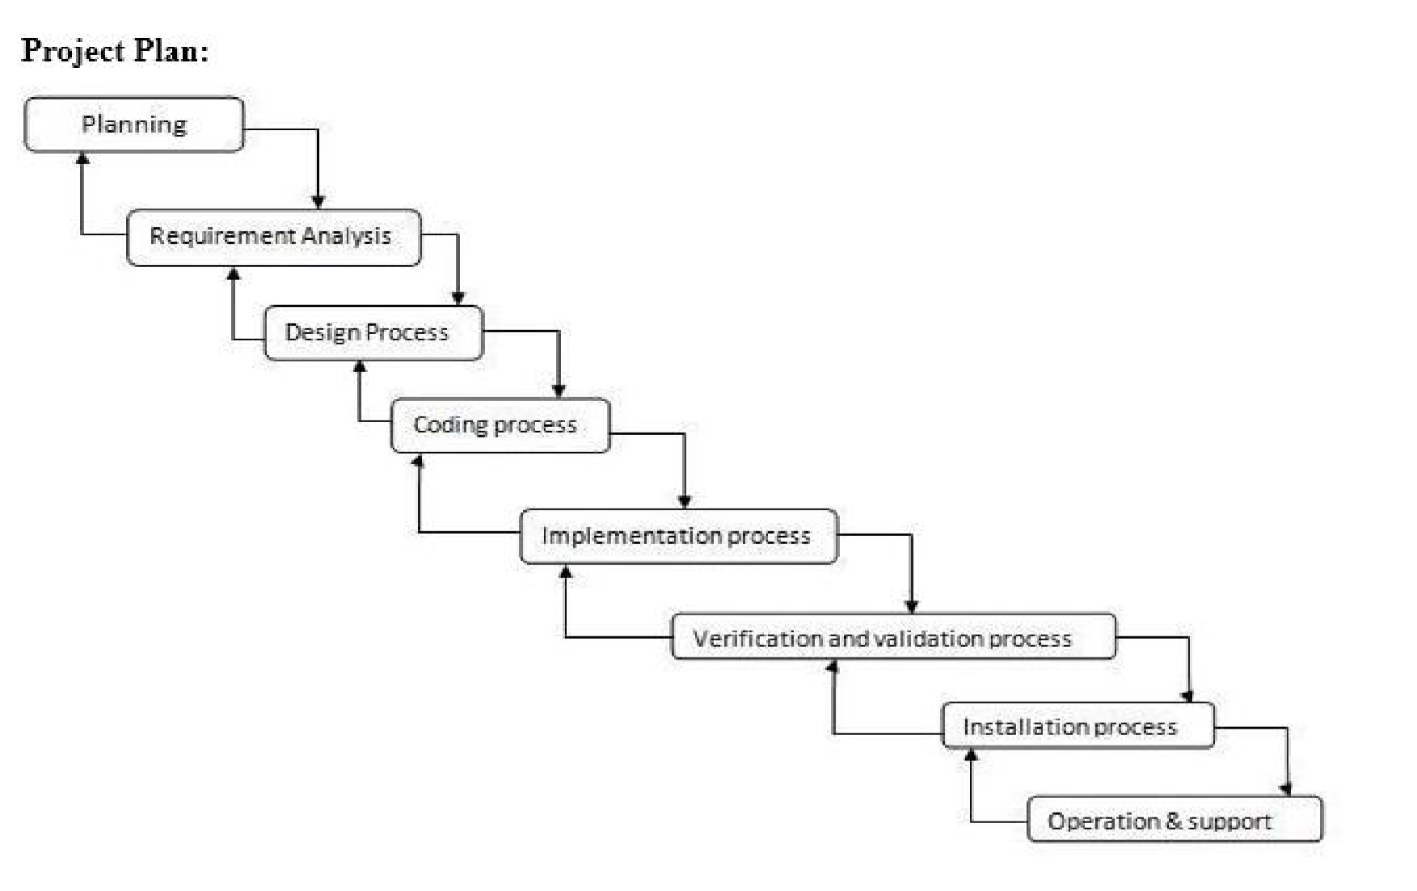

**Project task set**

A task is the work breakdown structure for the project

-no single task is appropriate for all projects and process models

-it varies depending on the project type and the degree of rigor (based on the influential actors) with witch the team plans to work.

The task set should provide enough discipline to achieve high software quality -but it must be a burden to the project team with unnecessary work.

Project task set are well defined according to following terms given below:

1)Define all the project task

2)Built an activity network that depicts their interdependences.

Identify the task that are critical within the network built a timeline depicting the time actual progress of each task.

Track the task by completing the milestones and record as completed.

Track a task progress to ensure that delay is recognized “one day” at a time.

To do this all the schedule should allow the progress to be monitored and the project to be controlled.

**Task network**

Purpose of a Task Network Also called an activity network It is a graphic representation of the task flow for a project It depicts task length, sequence, concurrency, and dependency Points out inter-task dependencies to help the manager ensure continuous progress toward project completion.

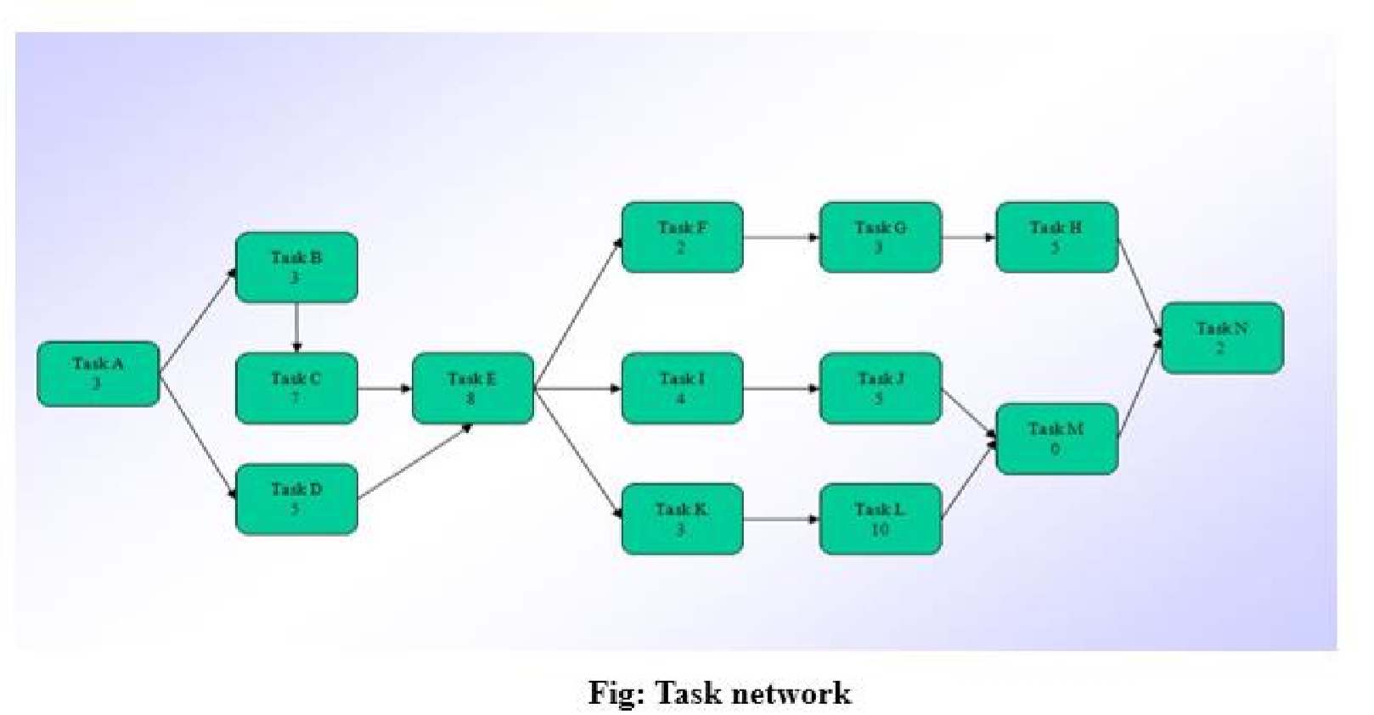

**Timeline chart**

**Work Task 1: Analysis Phase**

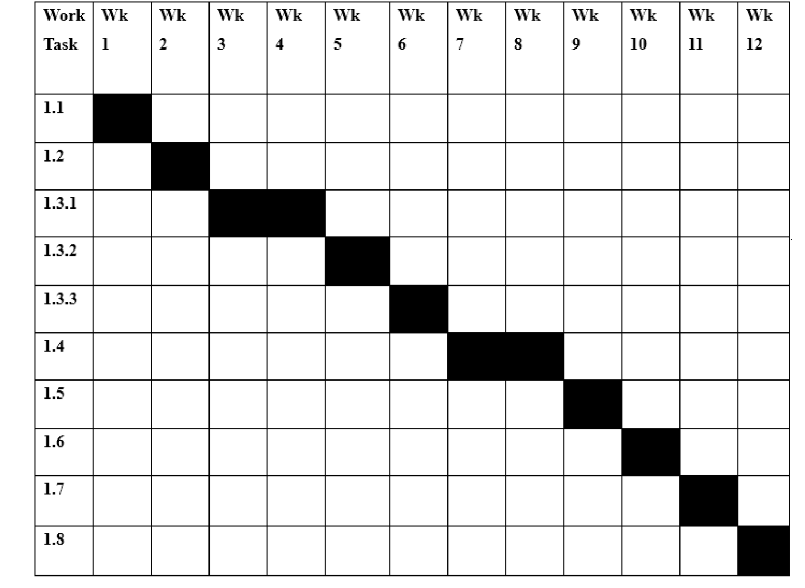

**Work Task 2: Design Phase**

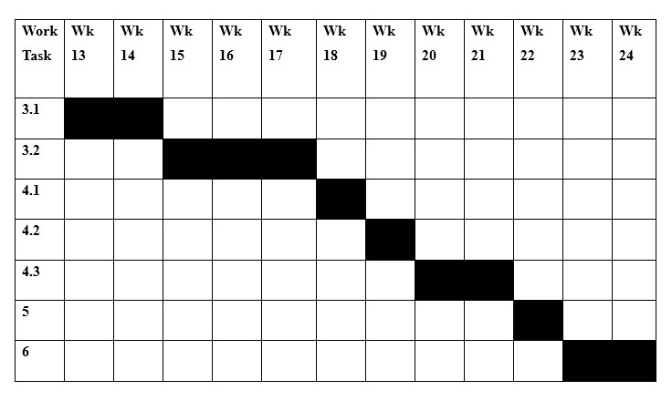

**Work Task 3: Coding, deployment and documentation phase**

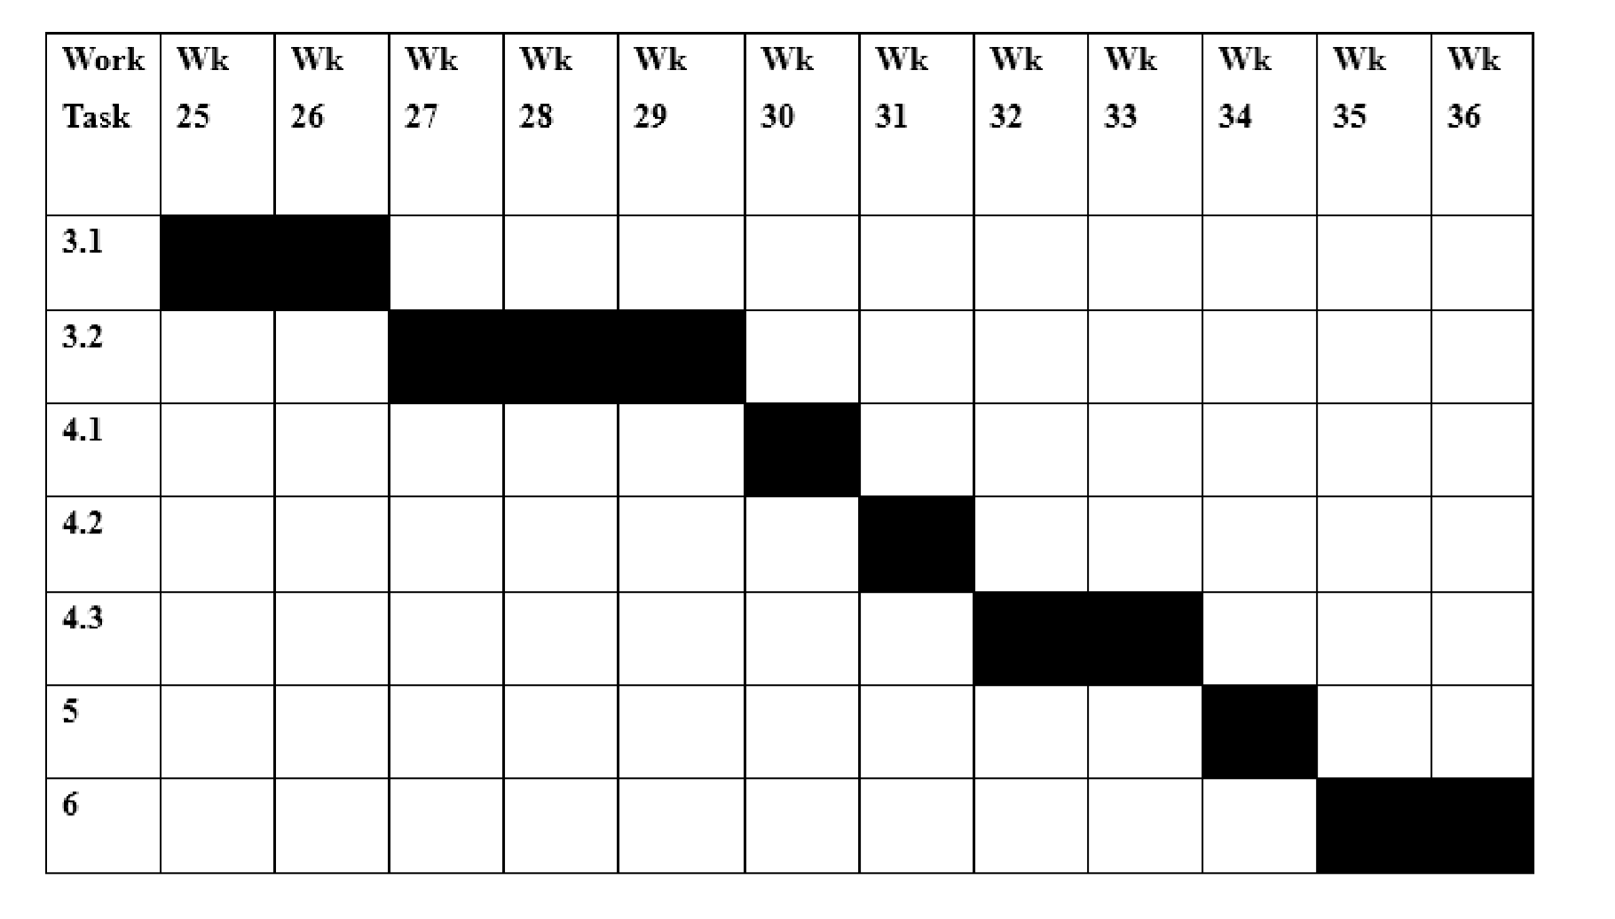

# System Design & Specification

**Software Requirements**

1. Operating System : Windows / Linux
2. My SQL
3. Xampp server

# System Design

**Architecture**

**Diagram**

**:**

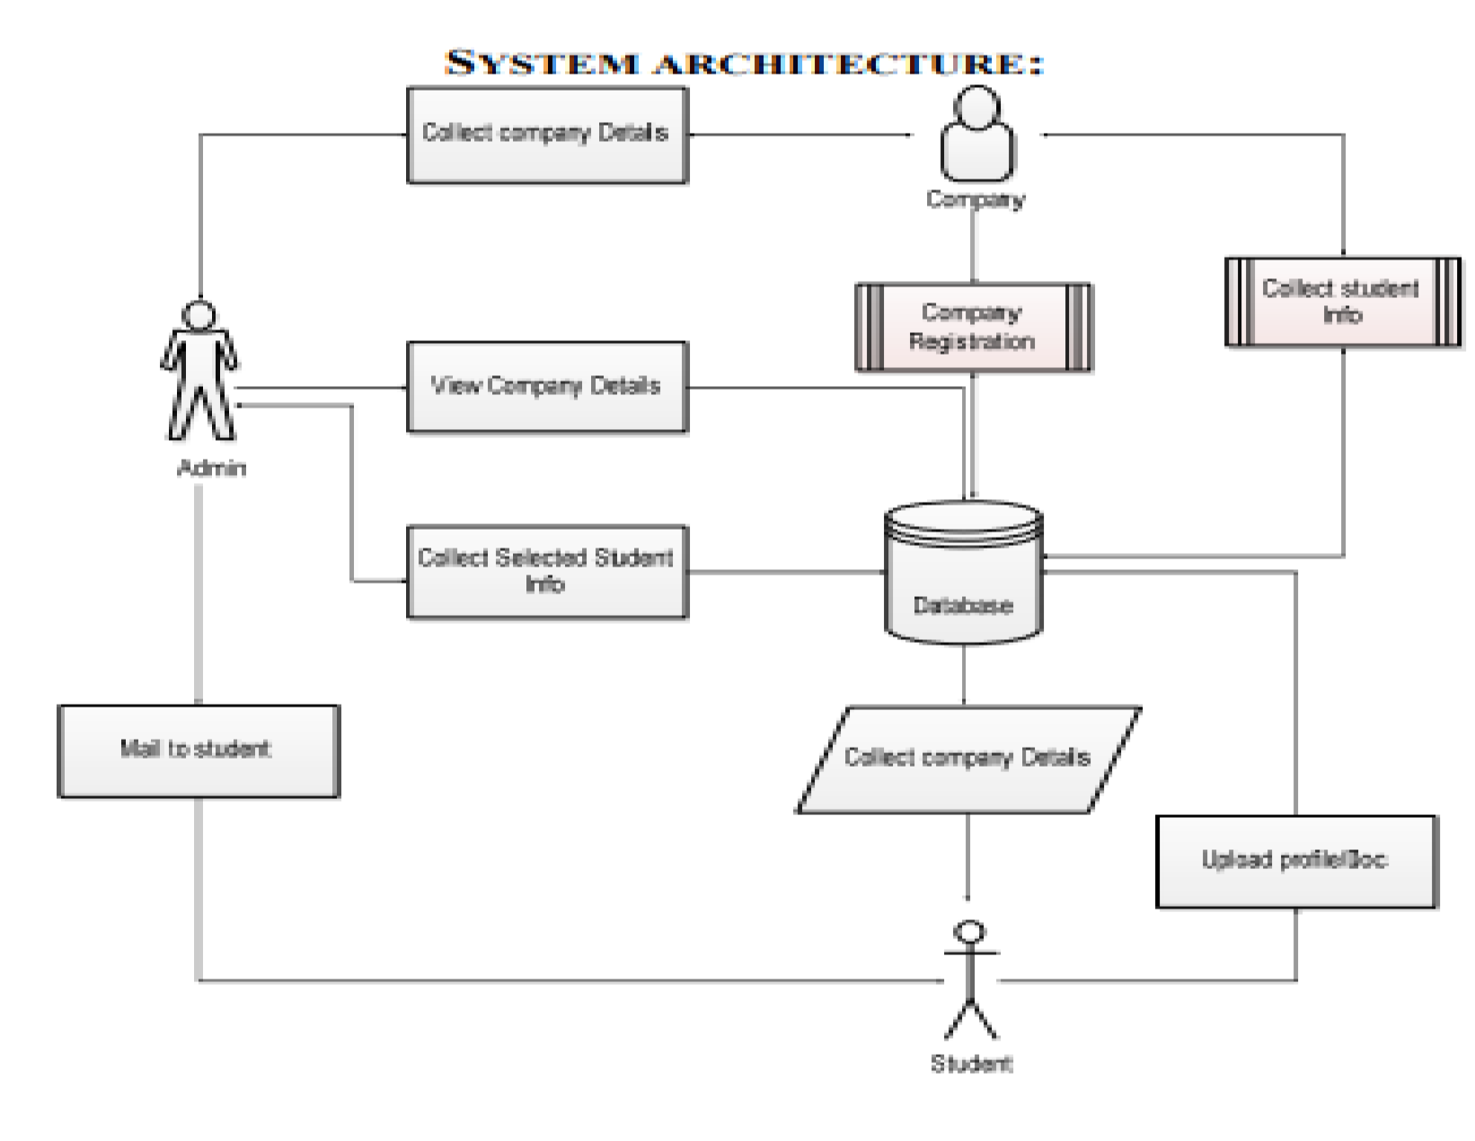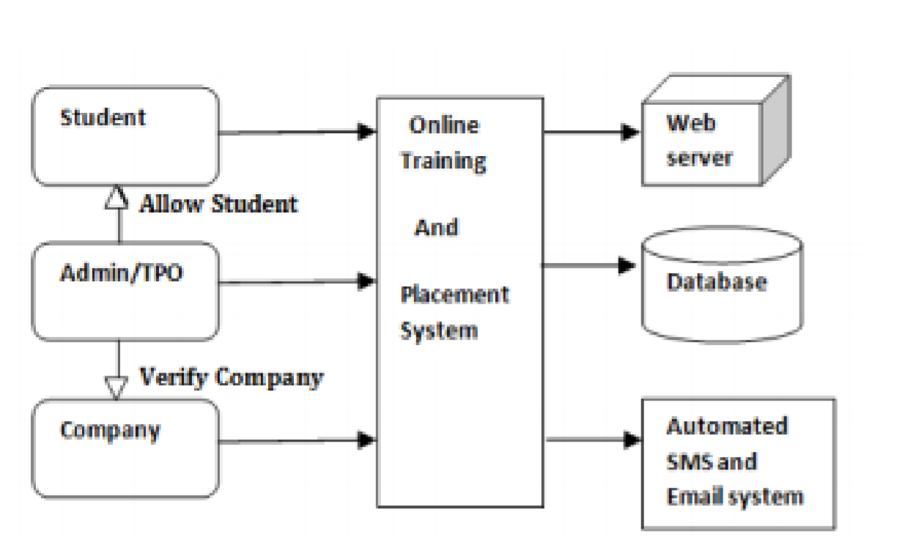

**DFD Level 0:**

It is also called a Context Diagram. It’s a basic overview of the whole system or process being analyzed or modeled. It’s designed to be an at-a-glance view, showing the system as a single high-level process, with its relationship to external entities.

Sometimes, it is called as a Context Diagram.

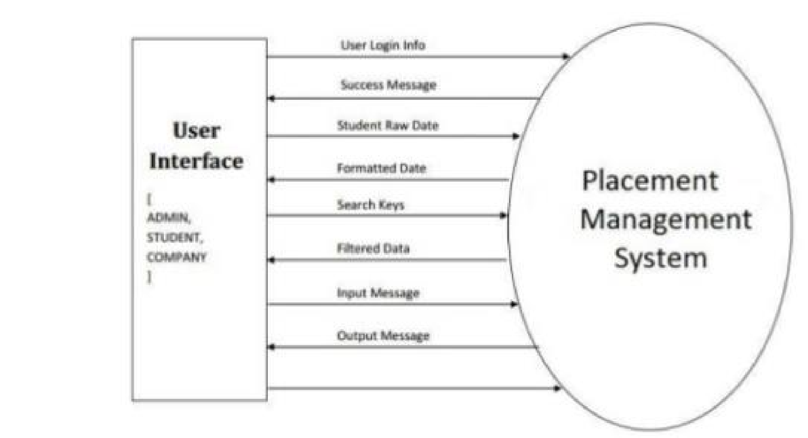

**Event Management :**

1.Students login and registration process

2.Admin can view details of students

**DFD Level- 1**

As described previously, context diagrams (level 0 DFDs) are diagrams where the whole system is represented as a single process. A level 1 DFD notates each of the main sub-processes that together form the complete system. We can think of a level

1 DFD as an “exploded view” of the context diagram

A level 1 data flow diagram (DFD) is more detailed than a level 0 DFD**:**

* It provides a more detailed view of the Context Level Diagram.
* Here, the main functions carried out by the system are highlighted as we break into its sub-processes.

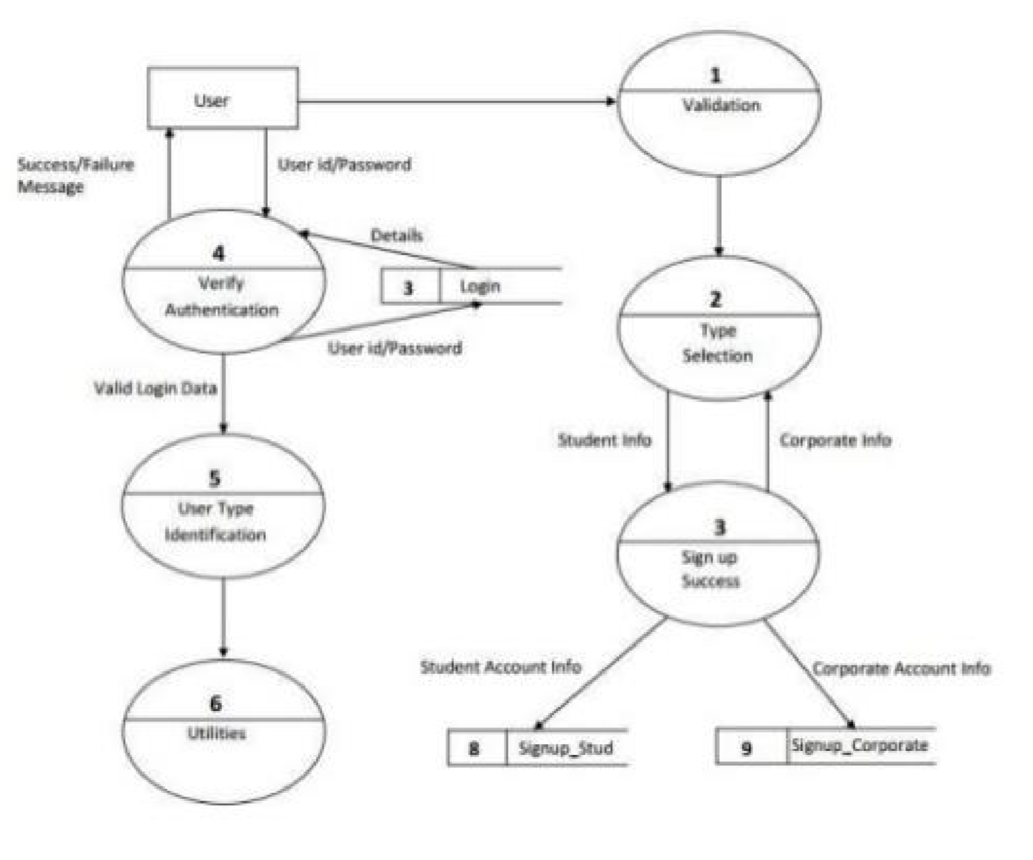

**DFD Level 2: For Student:**

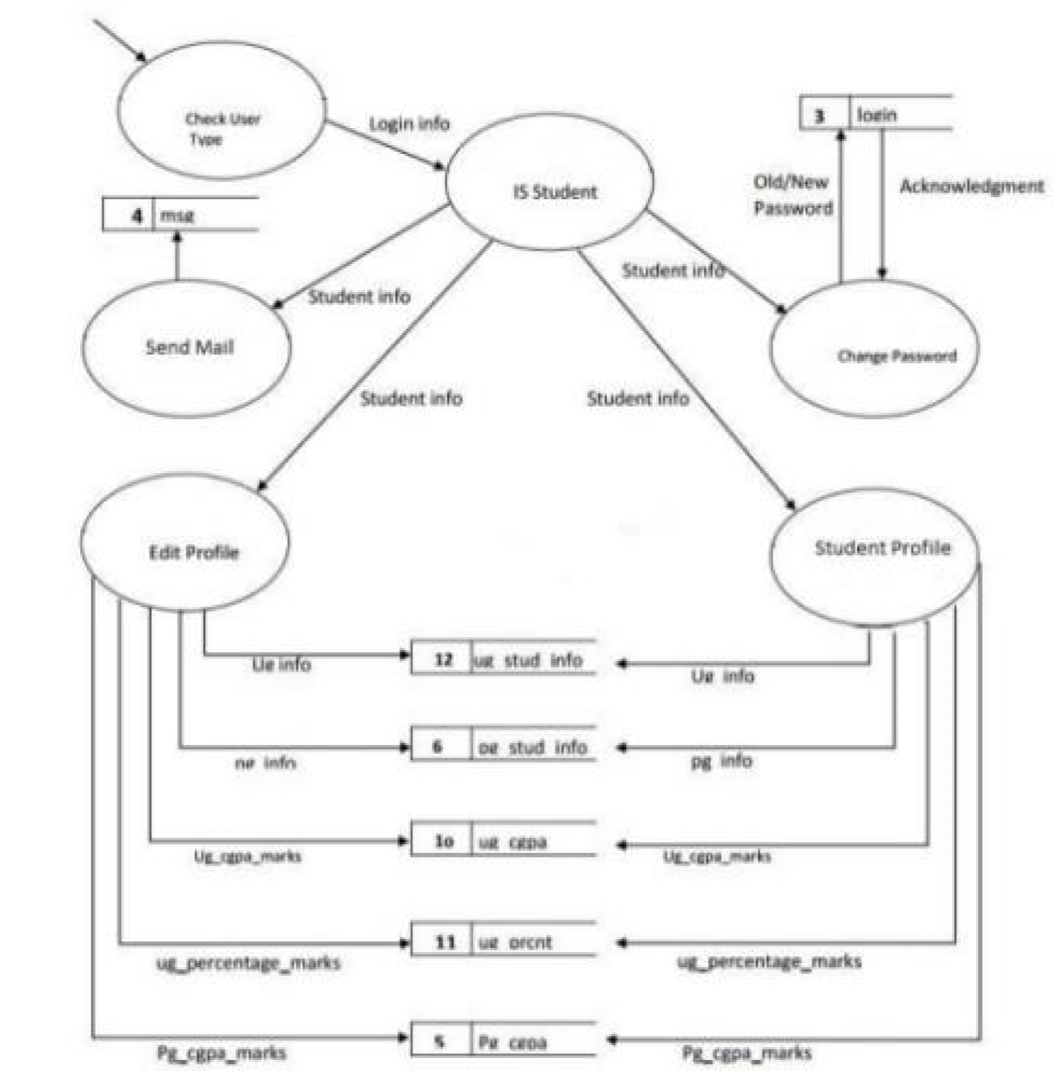

**DFD Level 2:For Admin:**

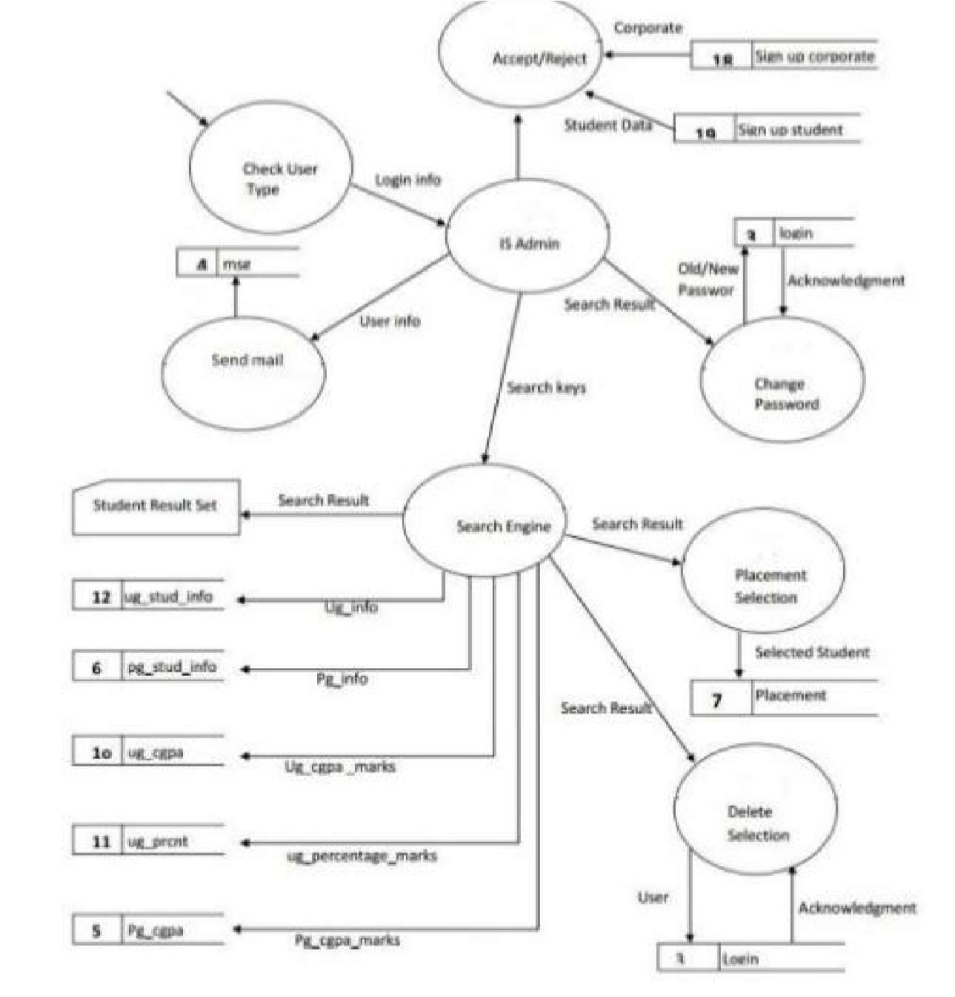

**Sequence Diagram**

Sequence diagrams are a popular dynamic modeling solution in UML because they specifically focus on lifelineor the processes and objects that live simultaneously, and the messages exchanged between them to perform a function before the lifeline ends.

**For Student:**

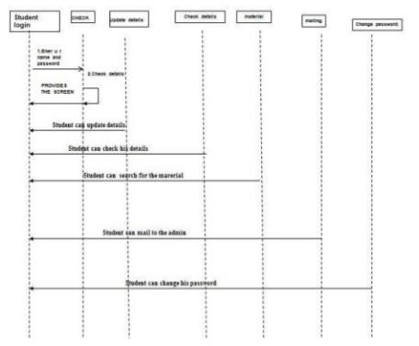

**Event Management:**

1. Students login and registration process
2. Students can check & update their details/ information
3. Students can change their username & password
4. Students can mail to the admin

## For Admin:

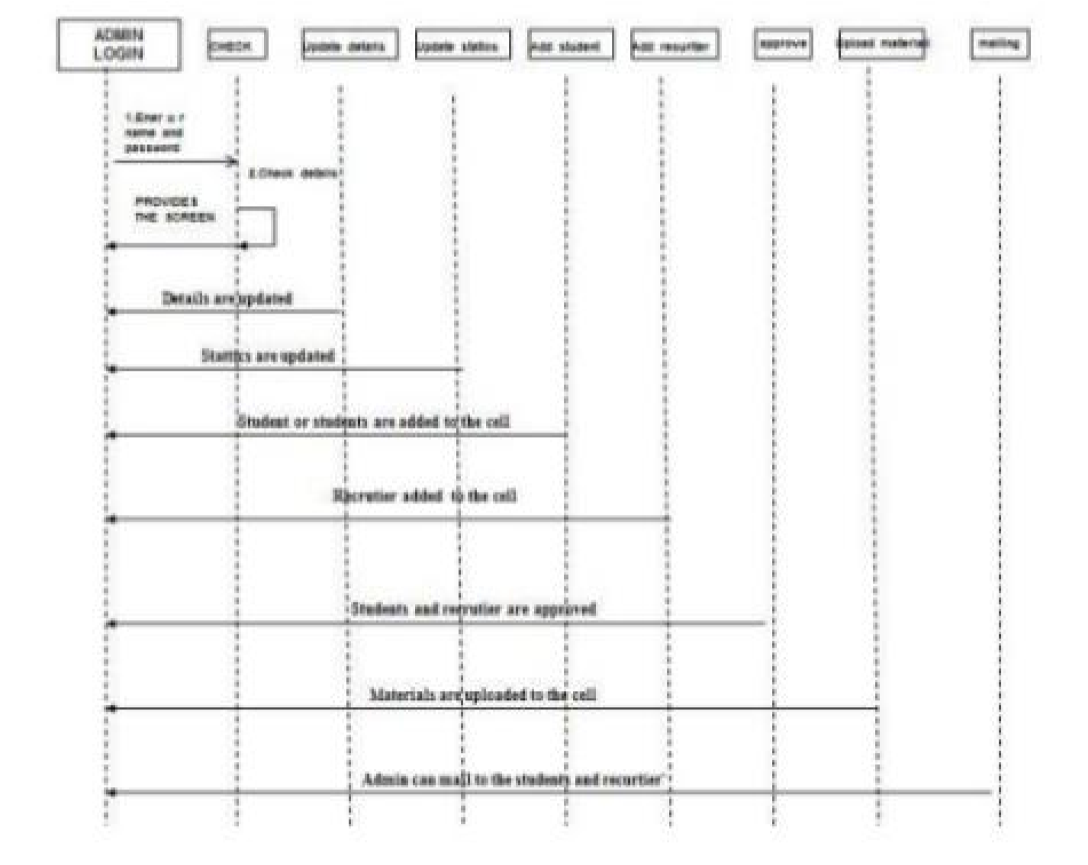

## Event Management :

1.Admin login & registration process

2.Admin adds the students & the receivers to the cell

3.Admin can view students and receivers details

4.admin can mail to the students & receivers

**Class Diagram**

Class diagrams are one of the most useful types of diagrams in UML as they clearly map out the structure of a particular system by modeling its classes, attributes, operations, and relationships between objects.

Class diagrams offer a number of benefits for any organization. Use UML class diagrams to:

• Illustrate data models for information systems, no matter how simple or complex.

Better understand the general overview of the schematics of an application.

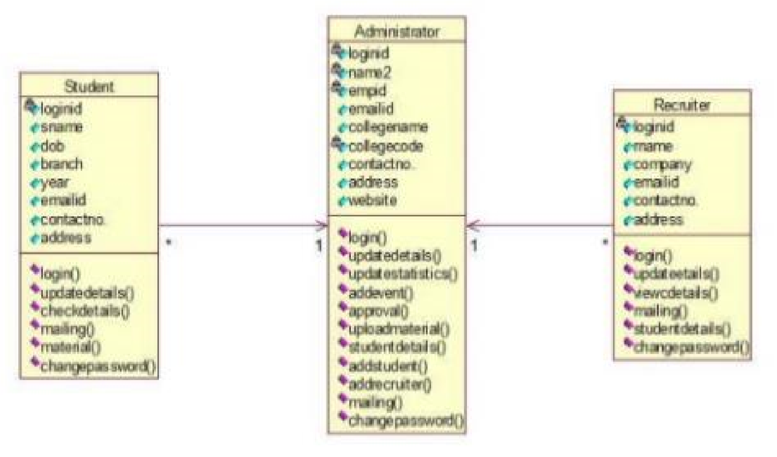

## Event Management :

1.Admin’s login. Admin can update the details of student & receiver, able to add events,can gives the approvals,uploads material,view student’s details, able to add students,receives(recruiters),can mail to students & receivers.

2.Student’ login. student’s can change & update the details, able to change their passwords and usernames, can mail to the admin.

3.Receiver’s login. Receiver’s view the details of students, can mail to the admin.

**Activity Diagram**

Activity diagram is another important diagram in UML to describe the dynamic aspects of the system. Activity diagram is basically a flowchart to represent the flow from one activity to another activity. The activity can be described as an operation of the system. The control flow is drawn from one operation to another. This flow can be sequential, branched, or concurrent.

The purpose of an activity diagram can be described as −

* Draw the activity flow of a system.
* Describe the sequence from one activity to another.
* Describe the parallel, branched and concurrent flow of the system.

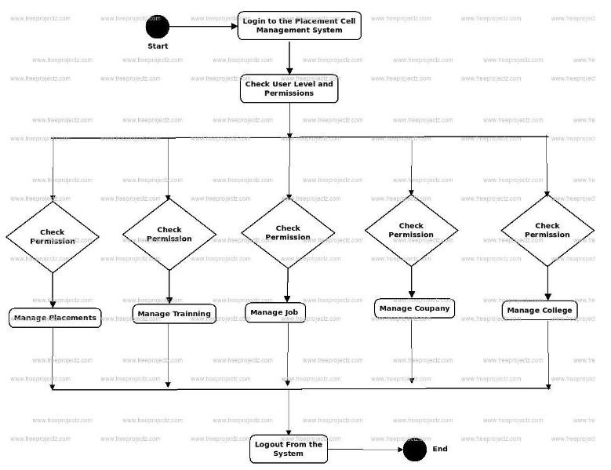

## Event Management:

1.Admin can change the permissions , manages placement & training records, manages college records as well as companies records.

**Deployment Diagram**

A UML deployment diagram is a diagram that shows the configuration of run time processing nodes and the components that live on them. Deployment diagrams is a kind of structure diagram used in modeling the physical aspects of an object-oriented system. They are often being used to model the static deployment view of a system (topology of the hardware). Purpose of Deployment Diagrams

* They show the structure of the run-time system
* They capture the hardware that will be used to implement the system and the links between different items of hardware.
* They model physical hardware elements and the communication paths between them .

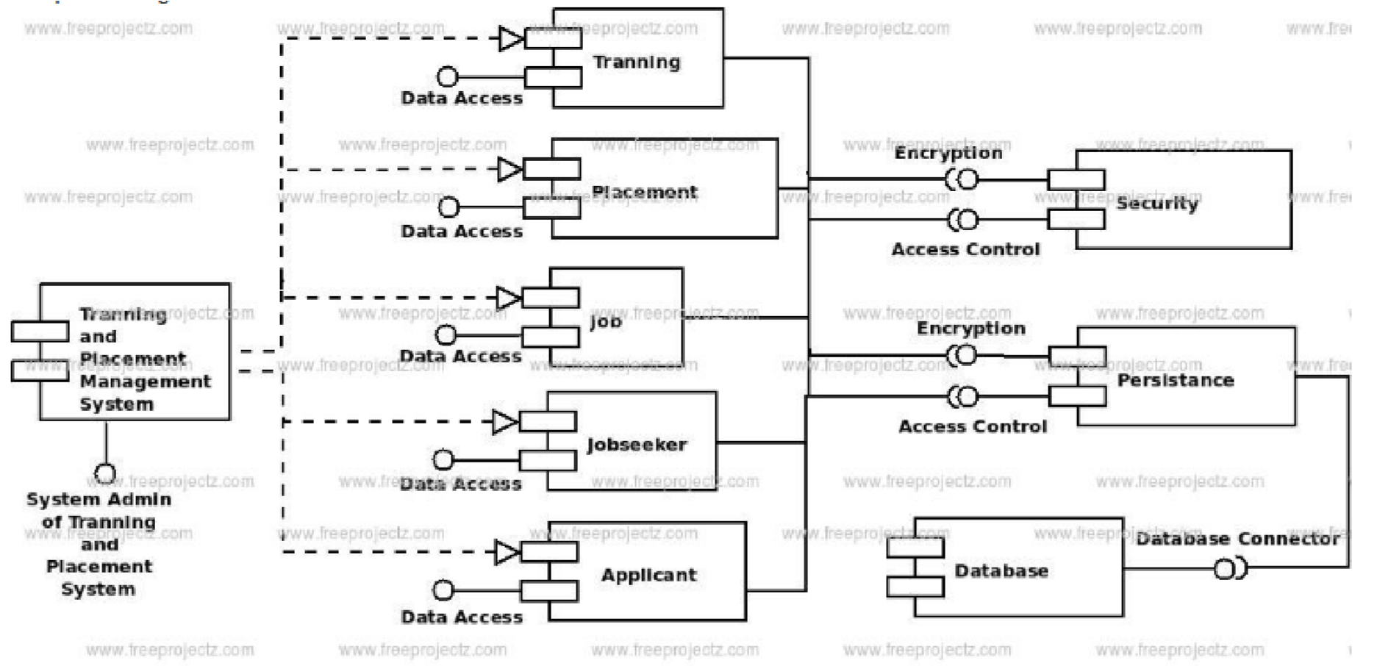

**Collaboration Diagram**

A collaboration diagram, also called a communication diagram or interaction diagram, is an illustration of the relationships and interactions among software object is in the Unified Modeling Language (UML). A collaboration diagram is a type of visual presentation that shows how various software objects interact with each other within an overall IT architecture and how users can benefit from this collaboration. A collaboration diagram often comes in the form of a visual chart that resembles a flow chart. It can show, at a glance, how a single piece of software complements other parts of a greater system.

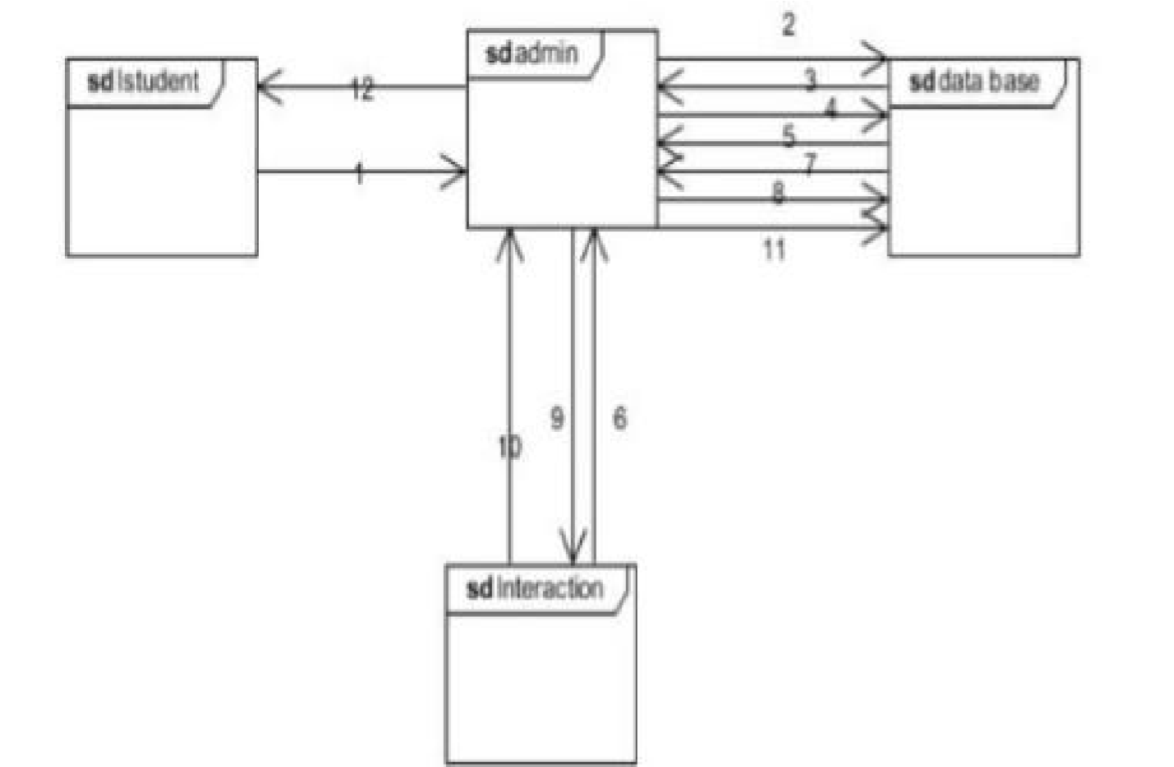

**Component Diagram**

Component diagrams are different in terms of nature and behavior. Component diagrams are used to model the physical aspects of a system.

The purpose of the component diagram can be summarized as −

* Visualize the components of a system.
* Construct executable by using forward and reverse engineering.
* Describe the organization and relationships of the components.

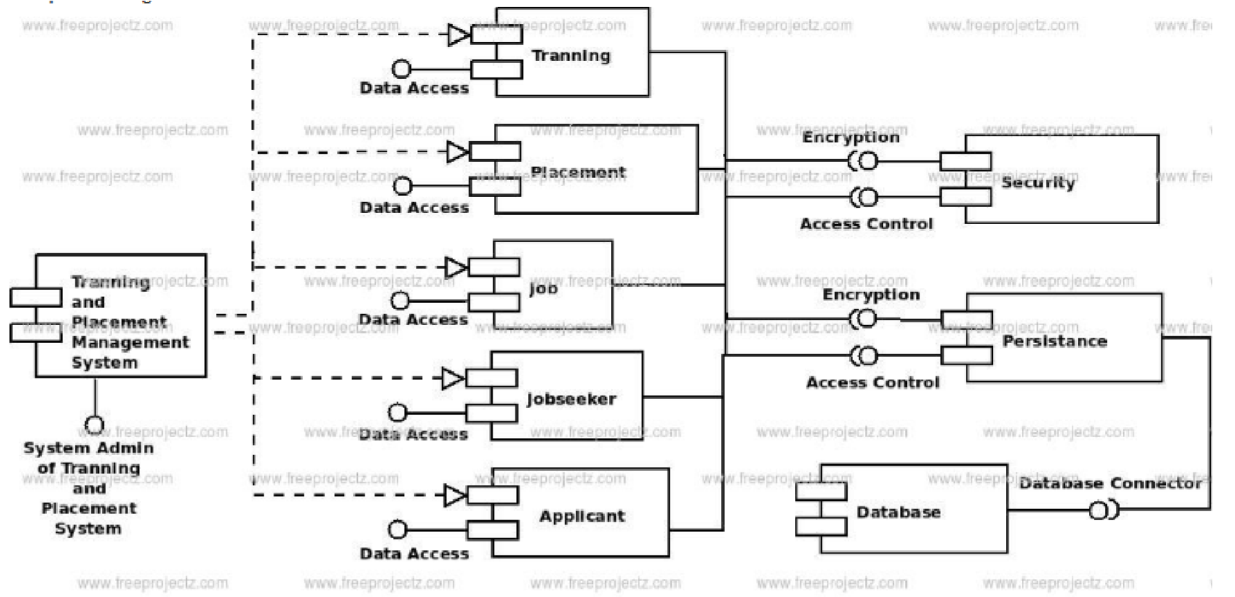

# Methodology Used for Implementation

**System Implementation plan:**

The biggest benefit of automation is that it saves labor. Our main objective was to save energy and materials and to improve quality, accuracy and precision with the help of this portal. According to our survey with the TnP coordiantors (TPCs) on most tough and annoying job that they have to do while working for Tnp department and what features they would like to see in the TnP web portal. Problems faced in existing system according to the survey conducted is as follows: • Notifying the students • Writing Invites to the companies • Mailing each and every student about company details and other information. • Providing list of eligible students as per company format which is different for each and every company.

According to survey results 70% of TPCs find company formatting a difficult job, 20% finds that notifying student a difficult task and last 10% find writing invites to companies an annoying task. Solutions to the above mentioned problems in existing system are as follows:

1. **Automated Mailers**

Automated mailers is a feature accessible by the TPO and TPCs. Mailing each and every company & students is a frustrating job, with the help of automated mailer TPO and TPCs can easily invite companies and also bulk emailing to student will be a much easier job.

1. **Company Format Automation**

As mentioned in the survey the most annoying task is to create a list of all the unplaced students that satisfy the company requirements because every company requires a different set of parameters and a different format, so formatting is done again and again which is a time consuming job so to reduce this problem a feature of company format automation is added in the web portal. This feature allows the company to filter the students as per their requirements and basic eligibility which is a win-win for both TPCs and Companies as they will get their job done much more easily. C. Notifying the Students Students generally faces a problem that they don’t get notified properly as some of them don’t uses WhatsApp or they don’t get a proper mail from the Training and Placement department. So to overcome this problem a notification system is added. With the help of this feature student will get notified. As a pop-up will be generated on their desktop notifying them of upcoming seminars, events and companies.

An implementation methodology is a collection of practices, procedures and rules that must be applied to perform a specific operation to provide deliverables at the end of each stage. The eight principles listed below is built from a collection of procedures to establish an effective implementation methodology framework. This framework provides flexibility to react and adapt to the unique requirements of every project, incorporating the principles of: 1. Project Management Planning

1. Scope Requirements Specification
2. Risk Issues Management
3. Communication Training
4. Quality Management

Experience Project Management Planning Project management is the art and science of communicating between individuals with different responsibilities, perspectives, and expectations so that the project team and the sponsoring organization perceive value and quality in the end product. The implementation process should be driven by solid project management principles and the concept of people working in tandem. The project manager drives the collaborative process so team members work together to accomplish agreed goals. Scope and Requirements Specification The implementation approach should have an outcomes-based focus. This means that the process emphasizes on identifying the business requirements that target an organizations specific goals and objectives. This is achieved through a systematic manner which sets out a solution roadmap that transforms goals and objectives into functional requirements (critical success factors, csfs). Risk Management

**Risk management**

Risk is associated with almost everything we do and is definitely associated with software implementation projects. A risk is something that may happen, implying a probability of less than 100percentage, and if it does transpire, will have an adverse impact on the project. If it has a probability of 100percentage, in other words, it occurs then it becomes an issue. Such an issue is handled differently to a risk. Risk management an effective methodology approach addresses risk management in four stages:

Stage 1: Identification

Stage 2: Quantification Stage

3: Response Stage

4: Control.

**Issue management** Issues are really problems. To solve the problem, an action must be assigned to someone who has to do something by a due date. Issues should be tracked by type, status and priority. The methodology should encapsulate the following steps when managing issues:

The methodology should encapsulate the following steps when managing issues:

1. Define what an issue is.
2. Keep log of issues that is easily accessible to everyone on the project.
3. Prioritize issues in terms of risk to project completion.
4. Assign an owner to the issue.
5. Most importantly, regularly monitor and report on the status of issues. Communication Training.

**Communication Communicate** formally, informally and frequently. Keep people informed so that they will support the outcome of the project, understand what they need to do and the implications, and alert the project team to issues. Communication should be targeted at two key groups stakeholders such as staff, management, regulators, contractors and the project team.

Training is essential for the uptake of the system by users. Some key considerations are: Scheduling training Too early and all will be forgotten; The audience involved The training strategy for management will be different for staff who are required to use the system as part of their day-to-day activities.

Quality Management Quality management ensures that the system meets or exceeds the customer expectations. It is a method for ensuring that all the activities, procedures and documentation required to implement a project are effective and efficient with respect to the system and its performance. The focus is not only on the product but also on how to achieve it. Post-Implementation Review This stage instigates learning from mistakes and identifying areas for improvement. In the context of quality management, this is the review stage. At project sign-of a project close-out meeting should be held with all members of the project team, including stakeholders. Usually held as a workshop scenario, project team members and stakeholders discuss and document project lessons learned in the form of project outcomes, significant issues, benefits and risks.

Documentation an implementation methodology must be well documented. The documentation should be content and audience-specific and usually comes in the form of: Procedure an overview of the methodology, its phases, milestones and deliverables. This type of documentation also includes templates that help promote efficiencies and streamline the implementation process. This type of documentation is aimed at the project team. Technical Describes the technical installation requirements for the information system. This type of documentation is aimed at a technical audience. End-User Refers to manuals for the end-user, system administrator and support staff. They include resources such as training manuals, training aides (such as PowerPoint slides) and automated training material (such as animations).

**Non functional requirement:**

**Performance Requirements:**

High Speed: System should process requested task in parallel for various action to give quick response. Then system must wait for process completion.

Accuracy: System should correctly execute process, display the result accurately.

System output should be in user required format.

**Safety Requirements:** The data safety must be ensured by arranging for a secure and reliable transmission media. The source and destination information must be entered correctly to avoid any misuse or malfunctioning. Password generated by user is consisting of characters, special character number so that password is difficult to hack. So, that user account is safe.

**Security Requirements**: Secure access of confidential data (user’s details). Information security means protecting information and information systems from unauthorized access, use, disclosure, disruption, modification or destruction.

The terms information security, computer security and information assurance are frequently incorrectly used interchangeably. These fields are interrelated often and share the common goals of protecting the confidentiality, integrity and availability of information; however, there are some subtle differences between them. User password must be stored in encrypted form for the security reason All the user details shall be accessible to only high authority persons. Access will be controlled with usernames and passwords.

**Result and Discussion**

The development of this project has many new areas of investigation. This project has wide scope to implement it at any University/Institution.

Objectives:

* To prepare students ready for industry employment.
* To provide Training and Employment opportunities for students .
* To provide industry institute interaction.

# Testing

In order to uncover the error present in different phases we have the concept of level of testing. The basic levels of testing are-

Client Needs Acceptance Testing

Requirement System Testing

Design Integration Testing

Code Unit Testing

**Fig. Levels of testing**

**UNIT TESTING**: -

It focuses verification effort on the smallest unit of software i.e. the module. Using the detailed design & the process. Specification testing is done to uncover the error within the boundary of the module. All modules must be successful in the unit test before the start of integration testing begins.

**INTEGRATION TESTING**: -

After the unit testing we have to perform the integration testing. The goal here is to see if the module can be integrated properly, the emphasis begins on the testing between module this testing activity can be considered as testing the design & hence the emphases on testing module interaction.

**SYSTEM TESING**: -

Here the entire software system is tested. The reference document for this process is the requirement document, & the goal of operating system to see if software meets its requirements.

**ACCEPTANCE TESTING**: -

It is performed with realistic data of the client to demonstrate that the software is working satisfactorily. Testing here is focused on external behavior of the system: the internal logic of the program is not emphasized.

**WHITE BOX TESTING**: -

This is the unit testing method where a unit will be taken at a time & tested thoroughly at a statement level to find the maximum possible error.

**BLACK BOX TESTING**: -

This testing method considered a module as a single unitand checks the unit as interface and communication with other module rather getting into details at statement level. Here the module will be treated as black box that will take some input and generate output. Output for given set of input combination are forwarded to the other module.

**Testing Plan**

Software testing is a critical element of software quality assurance and represents the ultimate review of specification, design and coding. Testing presents an interesting anomaly for the software engineer.

* **Testing Objective includes**

Testing is a process of executing a program with the intent of finding an error. A good test case is one that has a probability of finding an as yet undiscovered error. A successful test is one that uncovers an undiscovered error.

* **Testing Principles**

-All tests should be traceable to end user requirements

-Tests should be planned long before testing begins

-Testing should begin on a small scale and progress towards testing in large.

-Exhaustive testing is not possible

-To be most effective testing should be conducted by an independent third party.

**Test cases**

|  |  |  |  |
| --- | --- | --- | --- |
| TEST CASE | EXPECTED  RESULT | ACTUAL RESULT | RESULT STATUS |
| 1 | Login | Admin Login ,  Student Login ,  And Company Login | PASS |
| 2 | Registration | Registration Of Students And  Various Companies. | PASS |
| 3 | Check Details | Admin can check the details of every student and every company which is registered. Company can check the details of Students. | PASS |
| 4 | Schedule the dates | Companies will scheduled the date and time for the interviews of the students from various colleges.  For that students can send their CVs to that company. | PASS |
| 5 | Notification To  Students | Company sends the email or the message to the students whenever the interview is conducted. | PASS |

**Test results**

**WHITE BOX TESTING** (also known as Clear Box Testing, Open Box Testing,

Glass Box Testing, Transparent Box Testing, Code-Based Testing or Structural Testing) is a software testing metho[d](http://softwaretestingfundamentals.com/software-testing-methods/) in which the internal structure/design/implementation of the item being tested is known to the tester. The tester chooses inputs to exercise paths through the code and determines the appropriate outputs. Programming know-how and the implementation knowledge is essential. White box testing is testing beyond the user interface and into the nittygritty of a system.This method is named so because the software program, in the eyes of the tester, is like a white/transparent box; inside which one clearly sees.

**BLACK BOX TESTING**, also known as Behavioral Testing is a [software testing method](http://softwaretestingfundamentals.com/software-testing-methods/) in which the internal structure/design/implementation of the item being tested is not known to the tester. These tests can be functional or non-functional, though usually functional.

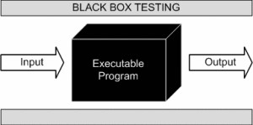

This method is named so because the software program, in the eyes of the tester, is like a black box; inside which one cannot see.

Black Box testing method is applicable to the following levels of software testing:

* [Integration Testing](http://softwaretestingfundamentals.com/integration-testing/)
* [System Testing](http://softwaretestingfundamentals.com/system-testing/)
* [Acceptance Testing](http://softwaretestingfundamentals.com/acceptance-testing/)

**UNIT TESTING:**

Unit testing concentrates verification on the smallest element of the program the module. Using the detailed design description important control paths are tested to establish errors within the bounds of the module. In this system each sub module is tested individually as per the unit testing such as campaign, lead, contact etc are tested individually. Their input field validations are tested.

**INTEGRATION TESTING:**

Once all the individual units have been tested there is a need to test how they were put together to ensure no data is lost across interface, one module does not have an adverse impact on another and a function is not performed correctly. After unit testing each and every sub module is tested with integrating each other.

**SYSTEM TESTING FOR CURRENT SYSTEM:**

Modules of the project. We are testing whether system is giving correct output or not. All the modules were integrated and the flow of information among different modules was checked.

It was also checked that whether the flow of data is as per the requirements or not. It was also checked that whether any particular module is non-functioning or not i.e. once the integration is over each and every module is functioning in its entirety or not. In this level of testing we tested the following: - Whether all the forms are properly working or not. Whether all the forms are properly linked or not. Whether all the images are properly displayed or not. Whether data travel is proper or not.

# Conclusion and Future Scope

## Summary & Conclusion

Our proposed system work according to IEEE paper. It can successfully login authorized person to system and register them. In our system admin can check the Student list those eligible according to criteria given by the Company and notify them instantly and update the information anytime successfully. Our system is Secure and User-friendly for all of three modules.

Increasing need of comfort and inculcating all the data at one place has always been a challenging process for everybody. With the introduction of this web based training and placement portal we promise to make the lives of students and administration a little easier by proposing an alternative for the current system being used. Easy accessibility and functioning of this portal will allow easy management of the allocation process during placement period. With the increasing demand of digitalization in every aspect of day to day activities we can anticipate the great demand for such portals in the near future and the comfort it will bring with it to the lives of all. Also the rapidly increasing concerns of global warming due to increase deforestation for large amount of paper that it requires we here have a minor role to save Mother Nature. So we hope all of you can sit back and relax and enjoy the luxury of Digitalization. More so in this busy and exhausting life we are saving one of the most crucial factor that keeps us running that is human energy.

## Future Scope

The main aim of developing this website was to reduce maximum chances of errors in manual work.

Save time for the process. Also students get notified by the SMS instantly.

Other features such as giving notification to students about the jobs that are available both on and off campus can be included in the upgraded versions. The system cannot provide the SMS integration. Hence, it can be modified to give the SMS integration. Other features like analytics can be added in future to this portal for tracking the progress of student in specific areas. After analysis this system will notify students of the areas they are lacking in.

## Limitations of project work

• Internet is necessary.

# Reference / Bibliography

1.Aswathappa K," Human Resource Management", Tata McGraw Hill, sixth edition, 2011.

2.Amit Dar et al., " Skill Development in India the Vocational Education and

Training System", Human Development Unit South Asia Region the World Bank. 510, 2006.

3.Archana Mantri, Sunil Dutta et al., "imbedding soft skills in technical studies: The problem based learning way", The Indian Journal of Technical Education, Vol. 30, pp. 79-83, 2007.

4.Gunderloy, Jorden BPB Publications (2000) - “Mastering SQL Server”

1. Luke Welling and Laura Thomson (5th Edition) - “PHP and MySQL Web

Development”

1. Roger S. Pressmen, T. Mc. GH. – Software Engineering (Theoretical Approach)
2. Thereon Willis Worx publications (2000) - “Beginning SQL Server”.